Assignment performed by Gaurav Amarnani, D7A Roll no. 67.
CG LAB 2 - Midpoint Ellipse Algorithm.

Aim: Implement midpoint Ellipse algorithm.

Theory:

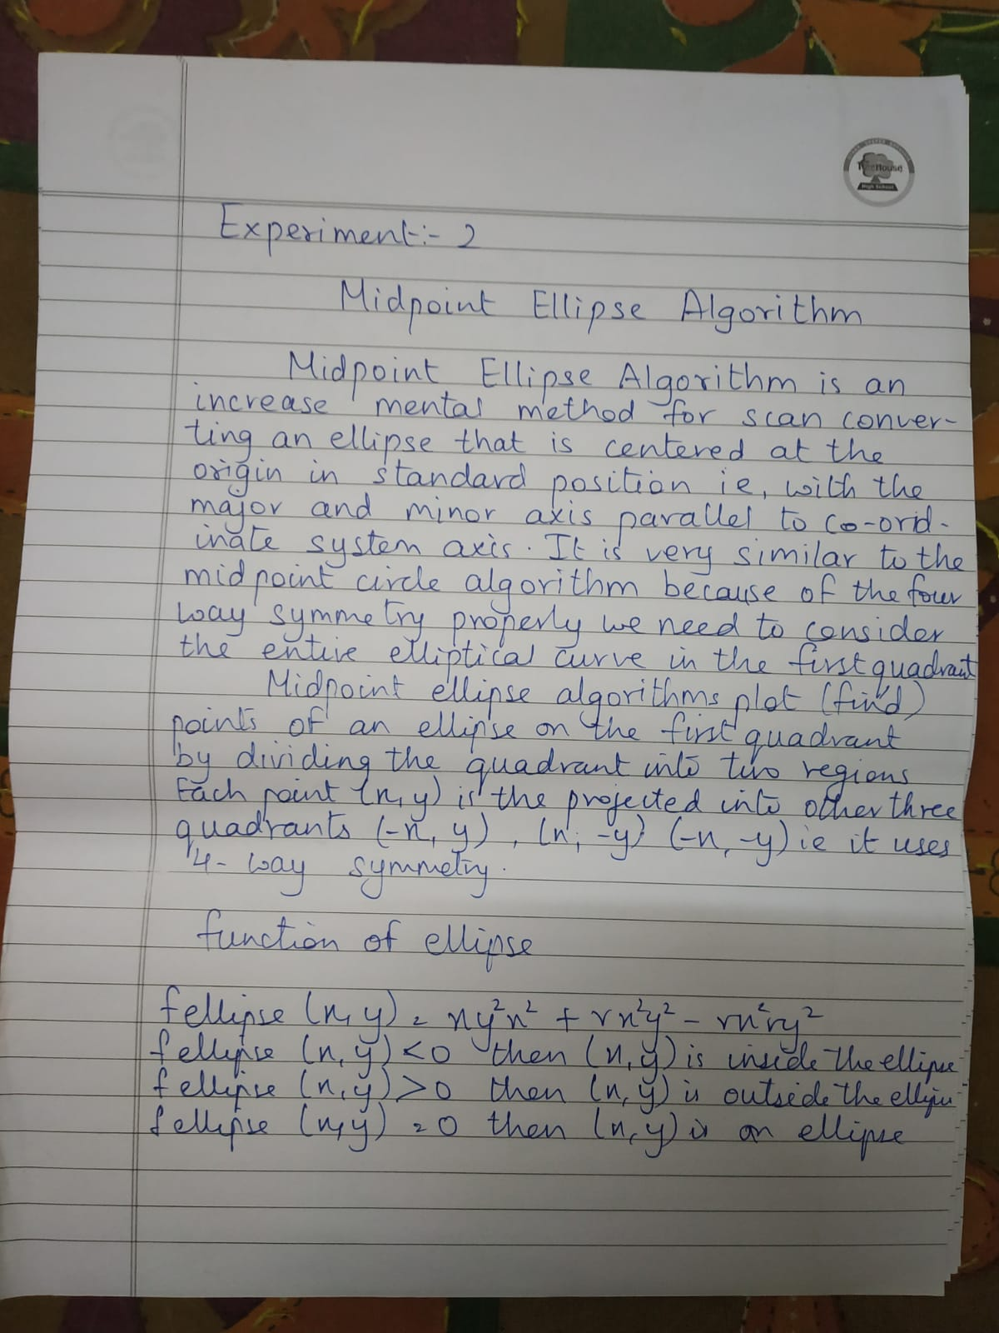

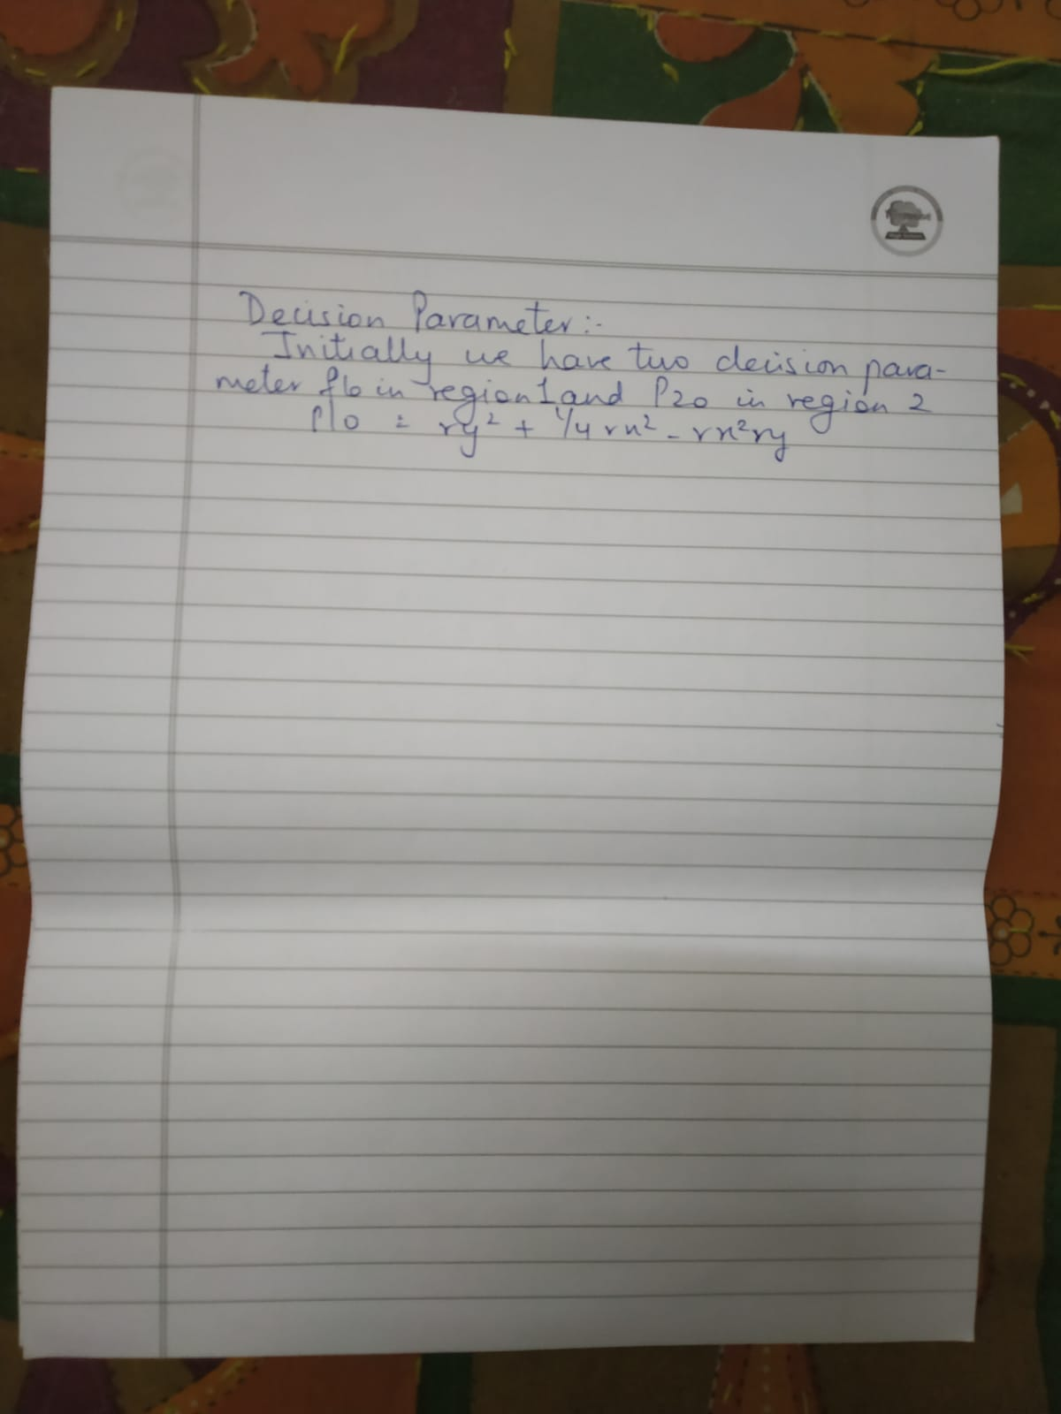

Algorithm:

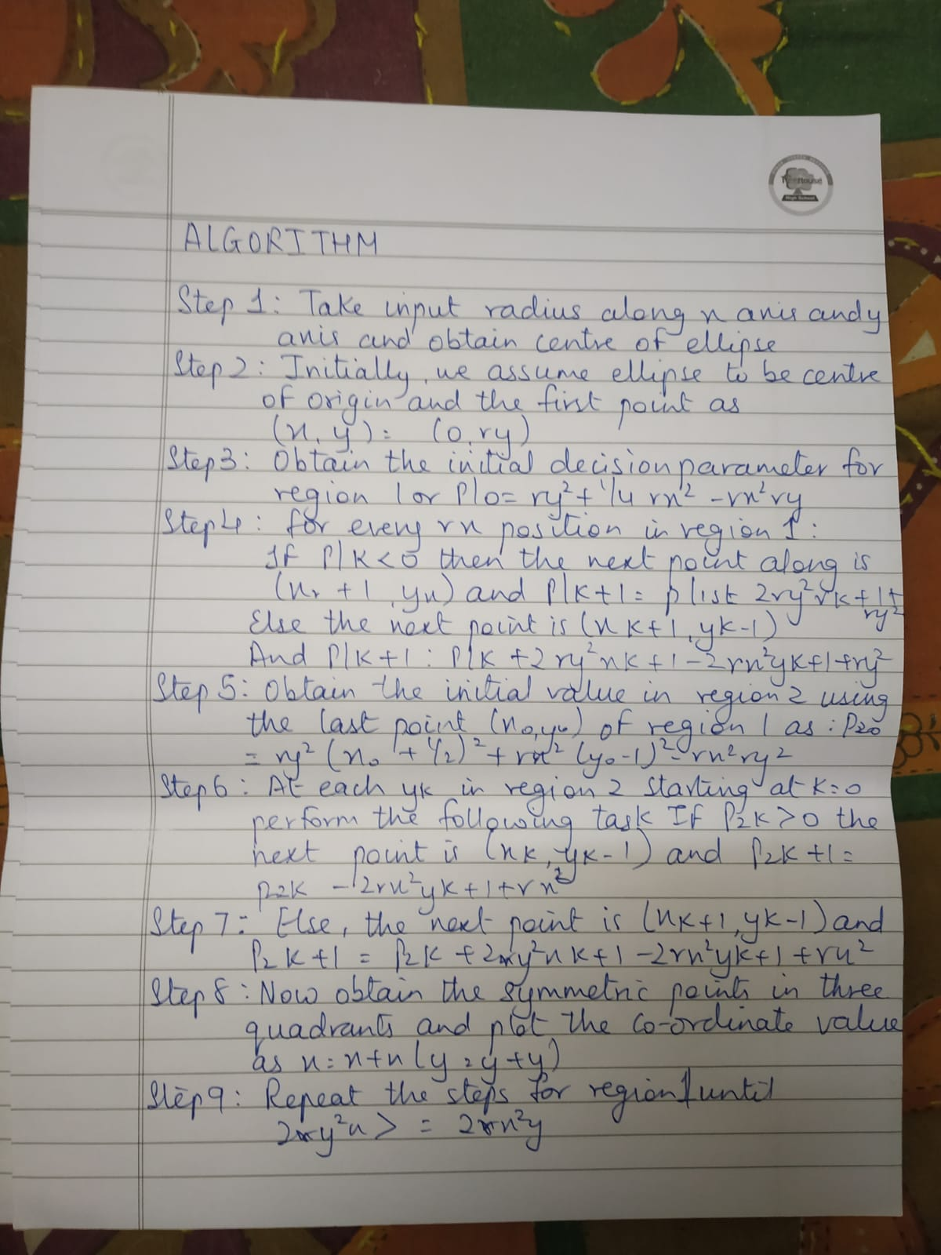

Program:

#include <stdio.h>
#include<graphics.h>
#include <stdlib.h>

//Performed by Gaurav Amarnani DSE CMPN.

void midptellipse(int rx, int ry, int xc, int yc) {

float dx,dy,d1,d2,x,y;
x = 0;
y = ry;
d1 = (ry * ry) - (rx * rx * ry) + (0.25 * rx * rx);
dx = 2 * ry * ry * x;
dy = 2 * rx * rx * y;
while (dx < dy) {
putpixel( x + xc, y + yc, WHITE);
putpixel( -x + xc, y + yc, WHITE);
putpixel( x + xc, -y + yc, WHITE);
putpixel( -x + xc, -y + yc, WHITE);

if (d1 < 0) {
x++;
dx = dx + (2*ry*ry);
d1 = d1 + dx+(ry*ry);
}
else {
y--;
dx = dx + (2 * ry * ry);
dy = dy - (2 * rx * rx);
d1 = d1 + dx - dy + (ry * ry);
}
}

d2 = ((ry * ry) * ((x + 0.5) * (x + 0.5)))+ ((rx * rx) * ((y - 1) * (y - 1))) - (rx * rx * ry * ry);
while (y >= 0) {
putpixel( x + xc, y + yc, WHITE);
putpixel( -x + xc, y + yc, WHITE);
putpixel( x + xc, -y + yc, WHITE);
putpixel( -x + xc, -y + yc, WHITE);

if (d2 > 0) {
y--;
dy = dy - (2 * rx * rx);
d2 = d2 + (rx * rx) - dy;
}
else {
y--;
x++;
dx = dx + (2 * ry * ry);
dy = dy - (2 * rx * rx);
d2 = d2 + dx - dy + (rx * rx);
}
}
}

void main() {
int gd = DETECT, gm;
initgraph(&gd, &gm,"c:\\turboc3\\bgi");
midptellipse(10, 15, 50, 50);
getch();
}


Output:

Conclusion:

